Chemical Effect on Concrete Over Time
Emory Gatchell, Mary Pate, Lilly Ratcliffe, and Hadley Saba
May 30, 2018
Roland Park Country School

Abstract
The salt that is applied to roads to prevent dangerous road conditions can have damaging effects on concrete over time, such as scaling, and chemical reactions resulting in the weakening of the chemical bonds within the concrete. The three most common road salts are MgCl₂, NaCl, and CaCl₂. To replicate the application of road salts on concrete, 12 concrete samples were used and each were soaked in either NaCl, MgCl₂, CaCl₂, or H₂O and observed over time. Each sample was soaked in its corresponding solution and testing included adding weights to the sample for 15 minutes while recording the before and after weight of the sample itself to test the deterioration of the concrete over time with weight. Over a course of 81 days, the concrete samples soaked in MgCl₂ had the largest weight gain for the overall sample and rebar. The concrete samples soaked in CaCl₂ had the largest weight loss overall, had the second largest rebar weight gain, and lost a lot of weight when being taken out of the solution for the brick appliance. The concrete samples soaking in NaCl and H₂O had barely any weight change overall, barely any rebar weight gain, and while H₂O had an immense weight loss, NaCl had minimal weight loss when being taken out of the solution. Through performing this experiment, CaCl₂ and MgCl₂ were the most damaging salts applied on the concrete, yet one can conclude. CaCl₂ had the largest effect on the concrete, CaCl₂ caused an average loss of 5g to the concrete soaked the CaCl₂ solution.

Introduction/Background
In Maryland, inclement weather becomes an issue when snow and/or ice prevents safe travel; so to resolve this issue, the Maryland Department of Transportation applies salt using different methods. Mussato, et. al. (2004) discovered that the three main application processes for snow and ice control are consisted of anti-icing, prewetting, and deicing. There are three common salts typically applied to the roads: MgCl₂, NaCl, or CaCl₂. Anti-icing is applying a freezing point depressant (such as MgCl₂, NaCl, or CaCl₂) to roads before snowfall, so that when the snow falls there is a barrier between the snow and the road. This process doesn’t allow the snow to freeze because the freezing point depressants delay freezing until extremely low temperatures. Freezing point depression is different for every chemical due to the chemical makeup up certain solutions. A solution occurs when a solute dissolved in a solvent, which is typically H₂O. In order to freeze or solidify a solution, the vibrational energy between the solute and solvent must be stopped which requires a temperature lower than that of the pure solvent, water. (pp. 59-62)
Mussato, et. al. (2004), found that these salts can have damaging effects on concrete over time, such as scaling, and chemical reactions resulting in the weakening of the chemical bonds of the concrete. Scaling is a process in which water freezes and expands on/in concrete, and when the ice thaws, gaps and cracks remain within the concrete. Magnesium chloride (MgCl₂) degrades and reduces the strength of concrete. When MgCl₂ reacts with C-S-H (calcium silicate hydrate), magnesium replaces the calcium in C-S-H (cement) through the process of double displacement, yielding M-S-H (magnesium silicate hydrate). Magnesium however, has a smaller atomic radius than calcium, which causes the ions to be smaller thus weakening the overall chemical binding; this is how magnesium chloride causes deterioration on a chemical level. Magnesium chloride also reacts with Ca(OH)₂, a strong base, and yields Mg(OH)₂, a weak base. This causes the pH to decrease which damages the rebar due to increased acidity, only increasing the speed of deterioration within the concrete, meaning that the concrete will deteriorate in a shorter amount of time. On a chemical level, the three salts all damage concrete because they are all chloride based, and chloride ions weaken the chemical bonds of concrete. Calcium chloride (CaCl₂) can cause deterioration similar to that of magnesium chloride, although the deterioration is often slower and less severe. When using sodium chloride (NaCl) surface distress is more likely to be caused by physical rather than chemical. All three of the chemicals can have negative impacts on the concrete; this experiment was designed to determine which salt solution (NaCl, MgCl₂, and CaCl₂) has the most damaging effects on the physical strength and appearance of concrete (pp. 60-63).

Methods
Twelve concrete samples were made following the Reinforced Concrete Sample Development guidelines. The concrete samples were soaked in 250 mL of their corresponding chemical which mirrored the application of road salts on concrete. The NaCl, MgCl₂, and CaCl₂ solutions were created by: First, a 1000 mL beaker was obtained. Then a certain mass of each chemical was weighed out (248 grams of NaCl, 412 grams of MgCl₂, and 480 grams of CaCl₂) and poured into their corresponding beaker. The beaker was then filled with water to the 750 mL line and stirred until fully dissolved. The negative control was only water with no present chemical in it.
The independent variable is the salt solution the concrete is exposed to: NaCl, MgCl₂, and CaCl₂. The dependent variables are the weight of the concrete after soaking in the solution, and after the brick was on the concrete sample as well as the damage recorded from observations. The variables chosen to control are: the mass of applied weight (supplied bricks), time weight is applied to concrete, use of the same electronic balance, controlling the amount of water the concrete is exposed to, creating perfectly saturated solutions for each salt at 10℃ and making sure the concrete is the same in the sense of creation.
The data recorded was the post-soak and post-brick weights, and the post-soak, and post-brick observations. A piece of rebar was put into each of the concrete samples before soaking in each individual solutions, so the weight and any beginning observations were recorded. Moreover, post-soak refers to the mass of each concrete sample after soaking in their specific solution for a certain amount of days. Post-brick refers to the mass of each concrete sample after having a brick on top of them for 15 minutes. Data was collected 6 times over the span of a 81 days where the concrete samples were weighed, bricks would sit on each sample for 15 minutes, then the sample would be weighed again. After the 6th data collection, the concrete samples were left out of the solution to dry. Then on the final day, each concrete sample was broken apart to retrieve the piece of rebar that was inside of it the whole time. The rebar was weighed and observed for any physical changes that could’ve been caused from the solutions.

Analysis
Figure 1: Average Change in Weight of Each Concrete Sample Over Time
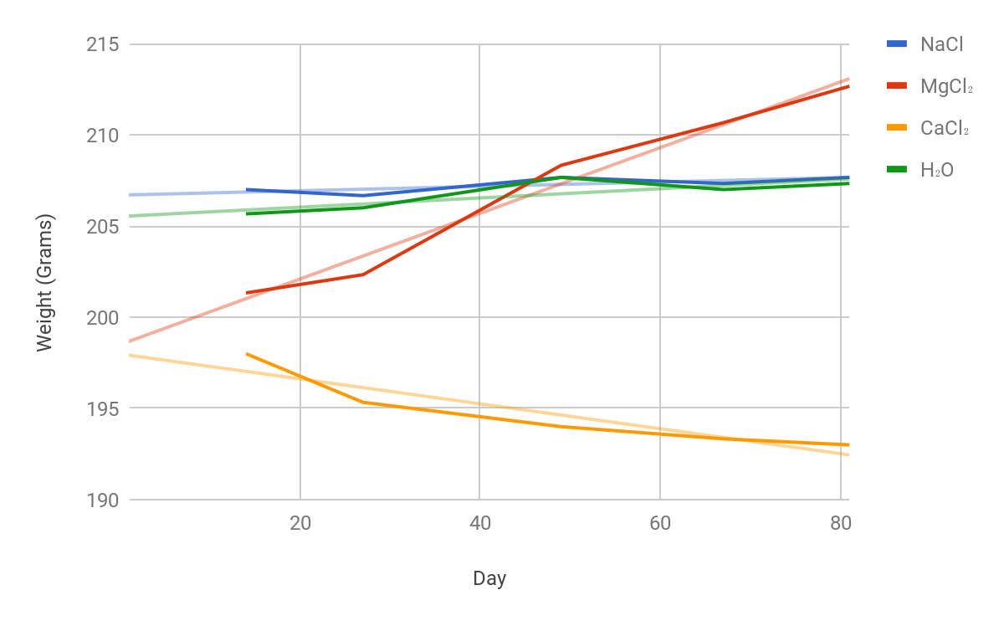
As seen in Figure 1, MgCl₂’s line of best fit has an increasing slope of 0.18 grams per day, which is the steepest slope of the four solutions. The R² value of the line of best fit is 0.977, showing that the obtained slope is a reliable representation of the collected data. These two pieces of data show that MgCl₂ has a large impact on the weight of the samples, and the increase is constant. CaCl₂ lost weight over time, as the solution’s line of best fit has a negative slope of -0.0683 grams per day. CaCl₂’s line of best fit also has a R² value of 0.86, which proves that CaCl₂’s samples lost weight over time at a constant rate. Furthermore, NaCl’s samples slowly gain weight over time, as reflected by the slope of the line of best fit, which is 0.012 grams per day. The slope reflects the change in weight of the sample per day. NaCl’s line of best fit is not linear with a R² value of 0.58. These two pieces of data show that NaCl did not have a large effect on the concrete samples, as it created neither a large change in weight or a continuous effect on the concrete.H₂O’s samples had little change over time (but a greater change than NaCl), as the slope of the solution’s line of best fit is 0.0254; the R² value of the line is 0.661, reflecting that the obtained slope is not an accurate representation of the data trends. This data shows that H₂O had an extremely small effect on the weight of the concrete over time. Day 0 was not included in this graph because none of the samples had been impacted by the solutions yet thus not accurately reflecting the impact of the solutions on the samples.

Figure 2: Average Weight Decreases Soak to Brick over 81 Days
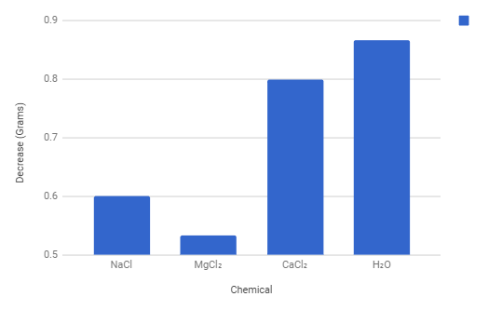
Figure 2 depicts the average decrease in weight that each sample underwent during the interval of removing the sample from the solution, and after placing a brick on the sample for 15 minutes. As shown in the graph, H₂O loses the most weight, with a decrease of 0.867 grams; CaCl₂ then loses 0.8 grams; NaCl loses 0.6 grams; and MgCl₂ loses 0.533 grams. This decrease occurred due to the gradual leakage of the solutions out of their corresponding concrete samples when being left out of the solutions on paper towels. This pattern occured to all samples, but the differing amounts is related to the size of the chemicals ionic radius.

Figure 3: Average Increase in Weight of Rebar over 81 Days
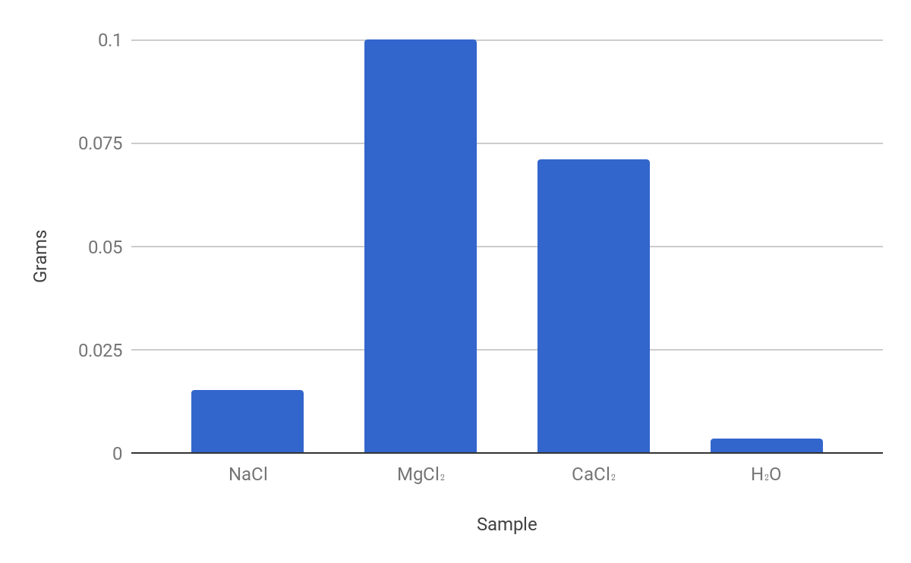
Figure 3 reflects the average change in weight of the rebar caused by the amount of rusting inside of the samples. This rust was evident on the rebar when the samples were broken. MgCl₂ had the most rusting, with an average increase in weight of 0.100 grams; CaCl₂ had the second most amount of rusting, with an average increase in weight of 0.071 grams; NaCl had the third most amount of rusting, with an average increase of 0.015 grams, and H₂O had the least amount of rusting, with an average increase of 0.003 grams.

Conclusion
In conclusion, MgCl₂ and CaCl₂ had the biggest effect on their corresponding concrete samples. This is evident through the data and comparisons between how each individual solution affected the concrete.
The concrete samples that were soaked in the MgCl₂ had the most drastic and long lasting weight gain. Since the MgCl₂ causes weight gain, this means that it stayed inside of each of the samples. Due to MgCl₂’s chemical interactions with the Ca(OH)₂ in the cement paste, it is known for opening the pores of the concrete; these pores were witnessed when the samples were broken. Small air bubbles were created in the previously smooth concrete. Once the MgCl₂ opens up the pores, it is able to react and stay within the concrete which would cause deterioration inside. This can be supported by the fact that MgCl2 has the largest ionic radius of the three chemicals, so during these chemical reactions the ions expand and are trapped inside the pores of the concrete. The mass of the concrete samples after the first day of collection had an average of 201.33g. The final average mass of the concrete samples after soaking and brick application was 212.67g. This is a 11.34g weight gain thus allowing for the solution to continuously affect the concrete. Moreover, the rebar that was inside of the concrete had a weight increase from its initial weight and to its weight after being inside the soaking concrete for a few months. Since the rebar inside of the MgCl₂ concrete samples had the greatest weight increase, it is clear that this rebar rusted the most, because as rust develops, it causes a weight gain. This was corroborated when, once the samples were cracked open, a dark orange rust was observed on the rebar of all of the samples. From the MgCl₂ affecting the concrete samples from within so drastically, it was able to cause rusting of the rebar thus adding weight to the rebar and the overall concrete sample.
Throughout the experiment, CaCl₂ continuously loses mass from the deterioration and scaling of the concrete. Aside from the initial weight gain from day 1 to day 14, due to the absorption of the solution, the CaCl₂ samples lost weight between each interval, and remained around an average of 93 grams for the last 2 data collections on days 67 and 81. CaCl₂ deteriorated the concrete, causing small pieces of the concrete fall off, this was observed for each data collection aside from the first two on days 1 and 14. The weight loss from the concrete caused by CaCl₂ shows the physical effects on the concrete from the salt. Also, the weight change post-soak to post-brick was larger than NaCl and MgCl₂, proving the concrete did not retain CaCl₂, and causing the samples to lose weight when the concrete was removed from the solution, as the solution leaked out over the duration of time between post-soak and post-brick. The average mass of the concrete after the first soak and first appliance of the brick was 197g. After all four trials, of soaking and applying weight, the average weight of the concrete soaked in CaCl₂ was 193g. Throughout the experiment the concrete, soaked in CaCl₂, lost an average of 5g. In addition to the concrete weight loss, it was discovered that the rebar had gained weight in rust. After cracking open the concrete sample to examine the rebar, it was revealed that there was an increase in rust of the rebar. With this addition of weight inside the concrete, it can be concluded that the concrete was solely responsible for the loss in weight. This shows that the CaCl₂ causes dramatic physical damage to the concrete, which resulted in its weakening, and eventual breakage, resulting in weight loss. all its weight and the rebar was slowing down the decrease of weight. This data proves that CaCl₂ had the greatest impact on the physical strength of the CaCl₂.
Figure 1 shows that the weight of the concrete soaked in the NaCl stayed consistent throughout the experiment, only showing a slight decrease then a slight increase. Research shows that when NaCl is applied to concrete, deterioration is most likely caused by the freezing and thawing process rather than chemical reactions. It is more likely that less extensive damage is done to the physical makeup of concrete with the chemical NaCl verse MgCl₂ or CaCl₂. This is due to how the chemicals affect the pH levels of the concrete because both MgCl₂ and CaCl₂ cause a decrease in ph whereas the NaCl raises the pH level suggesting that the threshold for the NaCl concrete sample was higher, thus causing the NaCl samples to not have a major weight change. After cracking open the concrete, it was observed that the NaCl samples had the least amount of rust and the weight increased the least (not including the negative control). This is because of the fact that the concrete sample itself was durable and did not gain a lot of weight, therefore the rebar only gained a minimal amount of weight. The rebar in NaCl and H₂O were similar. Rebar rusts when there is a small break in the concrete or exposure to water and from the previous data set which shows that the weight did not increase much, it supports the fact that the rebar did not rust a lot due to the lack of exposure/ weight gained by the concrete sample itself.
The slight weight gain experienced by the H₂O samples can be explained by the fact that the samples absorbed a small amount of water over time. This is corroborated by the fact that, though it was minimal, there was some amount of rusting on the rebar.
Although not simulated in this specific presentation, if these specific concrete samples were going to be freezed and thawed, a lot of damage would occur due to the lasting MgCl₂ solution within the concrete. If freezing and thawing were going to occur, the solution would be able to expand within the concrete which would overall cause physical deterioration. This conclusion that MgCl₂ causes an immense amount of physical damage is corroborated by the fact that the MgCl₂ samples became very cracked and dry over time, and were eventually, at the end of the experiment, were easy to crack open.
To further test which salt solution has the greatest effect on the physical and chemical makeup of the concrete, one could test the continuous effect that both the chemicals and the weight pressure (applied bricks) had on the cement samples without removing the samples from their solution. This could be executed by soaking the samples in their solutions, and keeping a brick on each sample nonstop for 80 days, and just having two data collections. This would prevent for any change in data do to the leaking of the sample from inside the sample.

Bibliography

Farnden, G., Gepraegs, O., Mussato, T., (2004). Relative effects of Sodium Chloride and Magnesium Chloride on Reinforced Concrete. Transportation Research Record, 1866, 59-66.
Razos, P. (n.d.). Solubility Curves [Chart]. Retrieved from http://www.dynamicscience.com.au/tester/solutions1/chemistry/solutions/solubilitycurves.html
Ropp, R. C. (n.d.). Solubility Table [Table]. Retrieved from https://en.wikipedia.org/wiki/Solubility_table

Appendix
- Independent Variable
  - Chemical the concrete is exposed to
- Dependent Variable
  - Weight of the cement post experiment
  - Damage recorded from observations
- Negative Control
  - Concrete in water
- List of Controlled Variable
  - Cement must be exactly the same in the sense of creation
  - Amount of water concrete is exposed to
  - Moles of chemicals
  - Mass of weight
  - Time with weight on
  - Use the same electronic balance
- Purpose: determine which salt has the greatest effect on the physical appearance and strength of the concrete
- Materials:
  - Cement
  - Sand
  - Distilled water
  - Ruler
  - Sharpie
  - Mixing bowl
  - Wooden paint stick
  - Graduated cylinder
  - Paper towel
  - Sand paper
  - 2/4 in rebar
  - 12, 3 oz paper cups
  - Analytical balance
  - Scoopula
  - Weigh boat
  - 3, 1000 mL beakers
  - 4 bricks
  - NaCl
  - MgCl₂
  - CaCl₂
  - H₂O
  - 12, 16 oz plastic cups
- Step-by-Step Procedure:
1. Create 12 reinforced concrete samples following the “sample development guidelines”
2. Remove the concrete samples from the mold
3. Label the concrete samples A-1, A-2, A-3, B-1, B-2, B-3, C-1, C-2, C-3, D-1, D-2, and D-3 with sharpie
4. Obtain 12 16 oz plastic cups and label them A-1, A-2, A-3, B-1, B-2, B-3, C-1, C-2, C-3, D-1, D-2, and D-3
5. Create a NaCl solution
a. Obtain a 1000 mL beaker
b. Weigh out 248 grams of NaCl in a weigh boat using an electronic balance.
c. Pour the 248 grams of NaCl into the 1000 mL beaker
d. Fill the beaker with water to the 750 mL line
e. Stir until fully dissolved
6. Divide the NaCl solution into the three 16 oz plastic cups (250 mL each) labelled A-1, A-2, and A-3
7. Create a MgCl₂ solution
a.Obtain a 1000 mL beaker
b.Weigh out 412 grams of MgCl₂ in a weigh boat using an electronic balance.
c.Pour the 412 grams of MgCl₂ into the 1000 mL beaker
d.Fill the beaker with water to the 750 mL line
e.Stir until fully dissolved
8. Divide the MgCl₂ solutions into the three 16 oz plastic cups (250 mL each) labelled B-1, B-1, and B-3
9. Create a CaCl₂ solution
a.Obtain a 1000 mL beaker
b.Weigh out 480 grams of CaCl₂ in a weigh boat using an electronic balance.
c.Pour the 480 grams of CaCl₂ into the 1000 mL beaker
d.Fill the beaker with water to the 750 mL line
e.Stir until fully dissolved
10. Divide the CaCl₂ solutions into the three 16 oz plastic cups (250 mL each) labelled C-1, C-1, and C-3
11. Pour 250 mL of water into the three 16 oz plastic cups labelled D-1, D-2, and D-3
12. Place the concrete sample into its corresponding plastic cup, let them remain for 10 days
13. Remove the concrete from the solutions using tongs, and place on labeled paper towels
14. Weigh each concrete sample using the analytical scale, and record the data in the “Chemical Effect on Physical Strength on Cement Over Time: ” in “Weight 1 (g)” (data table that responds to the specific label)
15. Place one brick on each block of cement for 30 minutes
16. Weigh each concrete sample using the analytical scale, and record the data in the “Chemical Effect on Physical Strength on Cement Over Time: ” in “Weight 2 (g)” (data table that responds to the specific label)
17. Record observations about each sample in the “Chemical Effect on Physical Strength on Cement Over Time: ” (data table that responds to the specific label)

Raw Data:

Rebar Before & After Mass and Observations
Concrete Sample | Before Testing | After Testing (Weight & Scale Rating Difficulty of Cracking Open: Observations)
A1 | 22.02g | 22.03g | 4: Dry smooth, little orange
A2 |  | 25.63g | 2: Dry smooth, little orange
A3 | 25.88g | 25.907g | 3: Dry, little orange
B1 | 25.59g | 20.61g | 4: Small pore, dark orange and yellow spots
B2 | 27.29g | 27.55g | 3: Smooth, dark orange and yellow
B3 | 20.60g | 25.62g | 4: Dry, chalky, orange
C1 | 20.96g | 21.11g | 3: Sooth, dark red rust
C2 | 20.76g | 20.78g | 3: Large pores, rusty bottom
C3 | 22.33g | 22.38g | 2: Large pores, soft rustic feel
D1 | 21.93g | 21.94g | 5: Few large pores, no rust
D2 | 17.05g | 17.04g | 5: Large pores, no rust
D3 | 20.86g | 20.86g | 4: Few pores, little rust

Chemical Effect on Physical Strength of Cement Over Time: NaCl [A]
Sample: | A1 |  | A2 |  | A3
Date/Status: | Weight: | Observations: | Weight: | Observations: | Weight: | Observations:
2/8/18 Pre-Soak | 198g | Grey, smooth sides | 201g | White veins, smooth sides | 203g | White veins on top
2/21/18 Post-Soak | 204g | Small white spot on bottom side, smooth | 207g | Crackling on top, small lumps on top, light cracks on side | 211g | Light cracks on top, lumps on one side of top
2/21/18 Post Brick | 204g | Veiny top | 207g | Veiny top, white lines on side | 210g | Lost a crumb
3/7/18 Post-Soak | 205g | Scaly top color, green water | 207g | Scaly color, white line where rebar fill happened | 210g | Clear film falls off, smooth crumbs on top
3/7/18 Post-Brick | 204g | A little white on slides | 207g | White tint | 209g | White tint
3/29/18 Post-Soak | 205g | White line on rebar placement | 209g | Grey, smooth sides, few grey lines | 211g | Grey, smooth
3/29/18 Post-Brick | 204g | Veiny top, small bumps | 208g | Veiny top, grey | 21lg | Veiny top, grey
4/16/18 Post-Soak | 204g | White line, two small bumps on top | 209g | Slimy, white veins on top | 211g | Slimy, white veins on top
4/16/18 Post-Brick | 204g | Small bumps still visible | 208g | White veins visible on top | 210g | slimy
4/30/18 Post-Soak | 205g | Scaly on top | 209g | Rust on bottom | 211g | Scaly on top
4/30/18 Post-Brick | 205g | dry/white | 208g | Small hole around side, dry, white | 210g | Chipped off spot on bottom

Chemical Effect on Physical Strength of Cement Over Time: MgCl₂ [B]
Sample: | B1 |  | B2 |  | B3
Date/Status: | Weight: | Observations: | Weight: | Observations: | Weight: | Observations:
2/8/18 Pre-Soak | 197g | Grey, smooth | 205g | Grey, smooth line in concrete where rebar is about | 199g | Grey, smooth
2/21/18 Post-Soak | 198g | White bottom, pointed top, light veins on top, smooth sides | 206g | White bottom light veins, small bump on top, smooth sides | 200g | White bottom light veins, rough edges around top
2/21/18 Post-Brick | 198g |  | 206g |  | 200g
3/7/18 Post-Soak | 199g | Bumpy top, white bottom, brown yellow water | 207g | Deteriorating on top, white bottom, rust on sides | 201g | Extremely slimy, white on sides and bottom, rust on bottom
3/7/18 Post-Brick | 199g | Still dark | 207g | Still dark, white veins | 201g | Lost crumb off top
3/29/18 Post-Soak | 207g | White layer all over cup and on the top of cement and rust on bottom | 214g | Rust on bottom of cement and cup. White all over cup and piece of cement | 207g | Rust on bottom of cup and cement, and white stuff everywhere
3/29/18 Post-Brick | 206g | Was left on brick for 16 min | 213g | Rust on bottom of cement and cup. White all over cup and piece of cemen | 206g | White thickness
4/16/18 Post-Soak | 209g | White layer on bottom of cup/top of concrete | 216g | White thick film on concrete and top | 209g | Hardened white salt visible
4/16/18 Post-Brick | 209g | White thick film | 215g | white thick film on concrete and top | 208g | Hardened white salt/film
4/30/18 Post-Soak | 211g | thick white layer on top/bottom | 218g | Rust & tick white layer on top/bottom | 212g | Cracked bottom, rusty/white layer
4/30/18 Post-Brick | 211g | Dry crackly white top | 217g | Rust on bottom | 210g | Thick white top

Chemical Effect on Physical Strength of Cement Over Time: CaCl₂ [C]
Sample: | C1 |  | C2 |  | C3
Date/Status: | Weight: | Observations: | Weight: | Observations: | Weight: | Observations:
2/8/18 Pre-Soak | 183g | Smooth sides, white veins on top | 203g | Smooth sides, grey, white veins on top | 200 | grey , smooth sides, white remains on top
2/21/18 Post-Soak | 198g | White cloudy grey on top, slightly bumpy on top | 201g | White cloudy grey on top | 197g | Sighty bumpy on top, white grey cloudy on top, slighty bumpy film around it
2/21/18 Post Brick | 197g | Slight film | 200g | Film, white | 197g | Film, white, smooth
3/7/18 Post-Soak | 194g | White on bottom, white slim coming off, salt on side, orange tint | 200g | Salt covered sides, thick white film on top and bottom, foggy white thick water | 194g | Slimy and scaly on the top, white film on bottom and top
3/7/18 Post-Brick | 194g | Slimy, slightly white film around it | 197g | Bumpy top, slimy | 195g | Sumpy top, slimy all around
3/29/18 Post-Soak | 194g | Slimy water and concrete | 199g | Slimy water and concrete | 194g | Slimy water and concrete
3/29/18 Post-Brick | 192g | Slimy film, and bumpy | 197g | Slimy film, bumpy top | 193g | Slimy film
4/16/18 Post-Soak | 192g | White/ slimy on bottom of the cup | 195g | Super slimy | 192g | Slimy
4/16/18 Post-Brick | 192g | Still slimy | 196g | Still slimy | 192g | Still slimy
4/30/18 Post-Soak | 192g | white/slimy | 198g | slimy/white bottom, rough top | 193g | Scaly top/ slimy
4/30/18 Post-Brick | 191g | Slippery white bottom | 195g | Slimy, crackly top | 193g | slimy/ crackly

Chemical Effect on Physical Strength of Cement Over Time: H₂O [D]
Sample: | D1 |  | D2 |  | D3
Date/Status: | Weight: | Observations: | Weight: | Observations: | Weight: | Observations:
2/8/18 Pre-Soak | 204g | Grey, crack in bottom, white veins on top | 204g | Crack on side, lump on top, grey | 188g | Grey, square shape, lumpy on top
2/21/18 Post-Soak | 212g | Wet but drying fast, smooth sides, light veins on top | 212g | Wet but drying fast, very round, bumpy top, smooth edges on top | 198g | Wet but drying fast, bumpy top, raised edges on top
2/21/18 Post Brick | 210g | Smooth, grey, veiny | 212g | Smooth edges/sides | 195g | Smooth and dry
3/7/18 Post-Soak | 214g | A little slimy but no different color/texture | 212g | Temporary white film, smooth, same structure, white flakiness on top/side when dried | 198g | White slime on top, same white dust on top
3/7/18 Post-Brick | 211g | After being out of solution, turned white | 212g | After being out of solution, turned white | 195g | After being out of solution, turned white
3/29/18 Post-Soak | 212g | White flakes on top | 213g | White flakes on top and in cup | 196g | White flakes in cup and top of concrete
3/29/18 Post-Brick | 213g | Dry white layer | 213g | Dry white layer | 197g | Dry white layer
4/16/18 Post-Soak | 213g | White flakes floating on top of water | 213g | crusty | 197g | rocky
4/16/18 Post-Brick | 213g | Thin white film, still bumpy top | 212g | Crusty, bumpy | 196g | White all around
4/30/18 Post-Soak | 213g | White film | 214g | White film | 197g | Empty cup, white, dried out, crackly
4/30/18 Post-Brick | 212g | White, dry, crackly on top | 213g | Bumpy top, thin white layer | 197g | White film surrounding

Calculations:
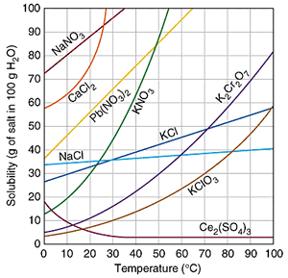

Substance | Formula | 0 °C | 10 °C | 20 °C | 30 °C | 40 °C | 50 °C | 60 °C | 70 °C | 80 °C | 90 °C | 100 °C
Magnesium chloride | MgCl₂ | 52.9 | 53.6 | 54.6 | 55.8 | 57.5 |  | 61 |  | 66.1 | 69.5 | 73.3

Perfectly saturated solutions for each salt at 10℃ (per 100 grams of water, so multiplied by 7.5):
NaCl: 33.06 → x7.5 = 248 grams
MgCl₂: 53.6 → x7.5 = 402 grams
CaCl₂: 64 → x7.5 = 480 grams

Pictures:
